* **[How to Edit the Top Link Navigation Bar](http://www.youtube.com/watch?v=leoA7t62vLo)**

**Case 1:**

1. **By using Edit: Edit =>Drag and drop**

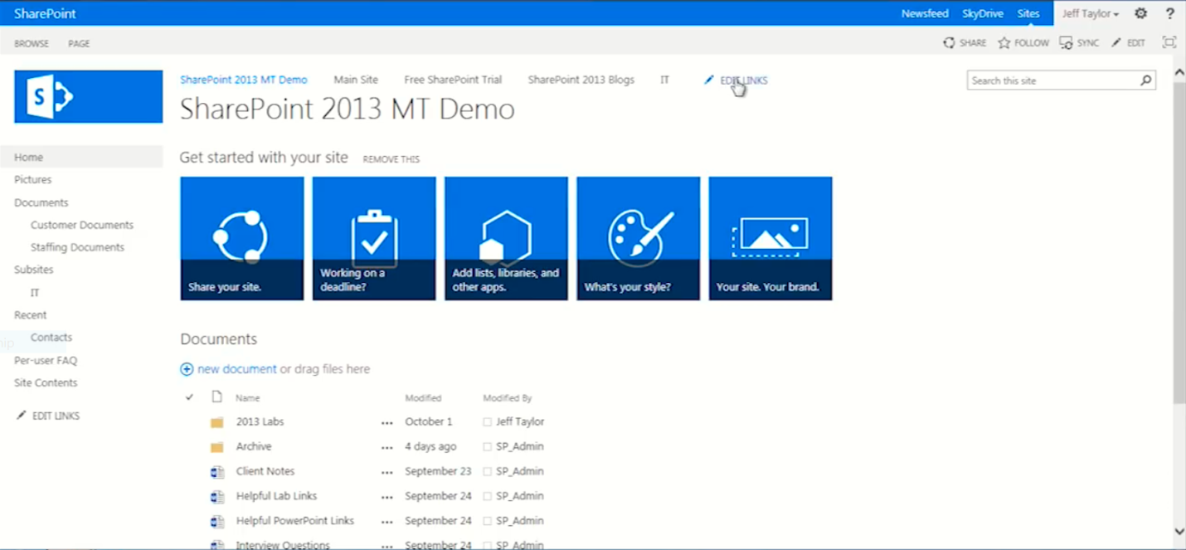

1. **Drag and drop titles under main title to do sub title**

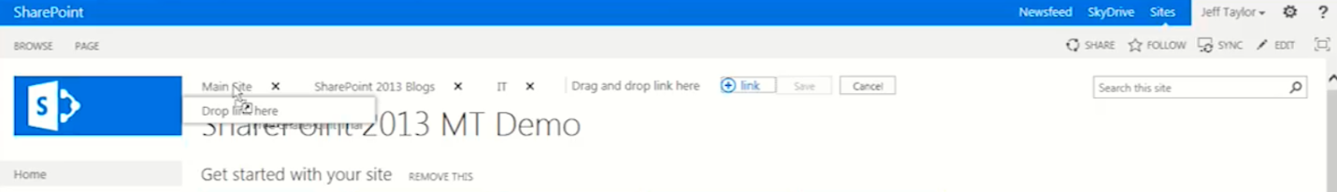

**Case 2: By using Setting**

1. **Setting ->site setting => Navigation =>Add -> Heading =>Title(Sub site) => Ok**

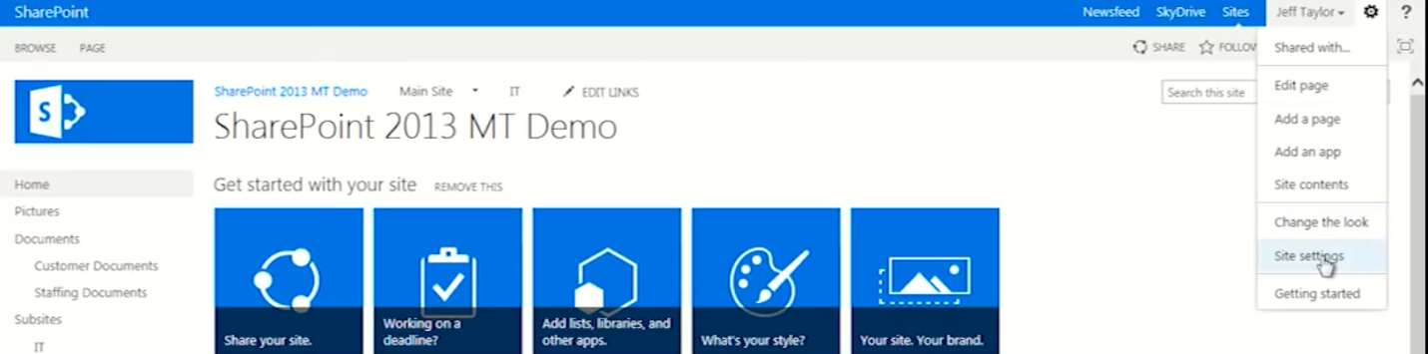

1. Site collection features

C:\Users\Nega\Desktop\paybill\PGW\s5.png

### First Activate: SharePoint Server Publishing Infrastructure

### C:\Users\Nega\Desktop\paybill\PGW\ss1.png

### Setting ->Navigation

### Add->Heading

### C:\Users\Nega\Desktop\paybill\PGW\s8.png

### C:\Users\Nega\Desktop\paybill\PGW\s10.png

### And then make another subsite under this subsite.